DIGITAL EVIDENCE MANAGEMENT

A Mini Project Report Submitted in Partial Fulfillment of the Requirements for the Award of the Degree of

MASTER OF COMPUTER APPLICATIONS (MCA)

Submitted by
Kiran HR , Lavanya K , B veena
Register Number: AF0505991, AF050516, AF

Under the Guidance of Mr. RAJESH KUMAR

Department of Computer Applications ACHARYA INSTITUTE OF GRADUATE STUDIES
Affiliated to Bengaluru City University BENGALURU – 2026

DECLARATION
I hereby declare that this project titled 'Smart Workload Optimization System' is a bonafide work carried out by me during the academic year 2026 under the guidance of Mr. Rajesh Kumar. This work has not been submitted elsewhere for any other degree.

ACKNOWLEDGEMENT
I sincerely thank my project guide Mr. Rajesh Kumar for his continuous support and guidance. I extend my gratitude to the faculty and management of Acharya Institute of Graduate Studies for providing the facilities required for the successful completion of this project.

INDEX

Chapter No. | Title
1 | Introduction
2 | Objectives of the Project
3 | Scope of the Project
4 | Feasibility Study
5 | Existing System
6 | Proposed System
7 | System Design
7.1 | ER Diagram
7.2 | Data Flow Diagram (DFD)
8 | Implementation
9 | System Testing
10 | Results and Discussion
11 | Conclusion and Future Enhancements
- | Bibliography
- | Appendix

CHAPTER 1 - INTRODUCTION

INTRODUCTION
With the rapid growth of digital crimes and the increasing reliance on electronic data in criminal investigations and legal proceedings, managing digital evidence has become a critical requirement for law enforcement agencies. In today’s digital era, the volume of electronic evidence has increased significantly, making traditional manual record-keeping systems inefficient and prone to errors, misplacement, lack of traceability, and security risks.
The Digital Evidence Management System (DEMS) is a console-based application developed using Java and MySQL. The system is designed to store, manage, track, and retrieve digital evidence in a structured, secure, and organized manner while ensuring accountability and data integrity.
The application provides role-based access control for administrators and officers. It maintains complete evidence details such as case ID, evidence description, collection date, status, and assigned officer. The system supports key functionalities including:
- Adding new evidence records
- Viewing evidence details
- Searching evidence by Case ID
- Updating evidence status
- Deleting evidence (Admin only)
- Case-wise and officer-wise tracking
- Structured report generation
This project demonstrates the integration of Java programming, JDBC connectivity, relational database management, SQL operations, and modular application design. The Digital Evidence Management System enhances transparency, improves operational efficiency, and reduces manual errors in evidence handling, serving as a reliable foundation for secure digital evidence management solutions.

CHAPTER 2 – Objectives

The Digital Evidence Management System (DEMS) is designed with the primary objective of providing a secure, structured, and efficient platform for managing digital evidence records. The system aims to replace traditional manual record-keeping methods with an automated and database-driven solution.
The detailed objectives of the project are explained below:

2.1 To Automate Evidence Record Management
One of the main objectives of this project is to eliminate manual evidence tracking methods that are prone to errors and misplacement.
The system automates evidence handling by:
• Storing records directly in a centralized database
• Enabling quick data entry and retrieval
• Reducing paperwork and manual documentation
This ensures faster operations, improved accuracy, and better record maintenance.

2.2 To Implement Role-Based Access Control
Security is critical in digital evidence management. Unauthorized access to sensitive case data can lead to serious consequences.
This system ensures:
• Separate roles for ADMIN and OFFICER
• Restricted access based on user role
• Admin-only permission for deleting evidence
• Officer-specific evidence viewing
This improves accountability and enhances system security.

2.3 To Maintain Proper Evidence Tracking
Tracking evidence throughout its lifecycle is essential for maintaining integrity.
The system maintains:
• Case ID for linking evidence to specific cases
• Officer name for responsibility tracking
• Date of collection
• Status updates (Collected, Under Investigation, Closed, etc.)
This structured tracking ensures transparency and traceability.

2.4 To Enable Case-Wise and Officer-Wise Filtering
Efficient retrieval of records is necessary in investigations.
The system allows:
• Searching evidence by Case ID
• Viewing evidence assigned to a specific officer
• Generating officer-wise reports
• Generating case-wise reports
This improves investigation speed and operational efficiency.

2.5 To Maintain Structured and Normalized Database Design
The project aims to implement a properly structured relational database with:
• Primary Keys (evidence_id)
• Secure login validation
• Organized data storage
• Reduced redundancy
The database stores:
• User credentials
• Evidence details
• Case references
This ensures data consistency and integrity.

2.6 To Demonstrate Practical Implementation of DBMS Concepts
This project serves as a real-time application of:
• Database Management Systems
• SQL queries (INSERT, UPDATE, DELETE, SELECT)
• Prepared Statements
• JDBC connectivity
• DAO design pattern
• Role-based authentication
It bridges the gap between theoretical database concepts and practical implementation.

2.7 To Improve Transparency and Accountability
By maintaining structured digital records, the system ensures:
• Clear officer responsibility
• Proper evidence documentation
• Reduced chances of tampering
• Better monitoring and reporting
This enhances trust and operational transparency.

2.8 To Provide a Scalable Foundation for Future Enhancements
The system is developed using a modular approach, allowing future upgrades such as:
• GUI-based interface
• Password encryption
• Audit logs
• PDF report generation
• Cloud-based database integration
• Email notification system

CHAPTER 3 – Scope

SCOPE OF THE PROJECT
The scope of the Digital Evidence Management System defines the boundaries, applicability, and future enhancement possibilities of the system. This project is designed to provide a structured, secure, and database-driven mechanism for managing digital evidence records within investigative organizations.
The system focuses on secure storage, role-based access, efficient retrieval, and organized tracking of evidence using relational database concepts.

3.1 Organizational Scope
- The system can be implemented in organizations where digital evidence handling and record tracking are essential. These include:
- • Law Enforcement Agencies
• Cyber Crime Investigation Units
• Forensic Departments
• Legal and Judicial Organizations
• Investigation Departments
• Government Regulatory Authorities
- In these environments, proper documentation, secure storage, and quick retrieval of evidence are critical for legal and investigative processes.

3.2 Functional Scope
- The Digital Evidence Management System provides the following functional capabilities:

1. User Management
- • User login authentication
• Role-based access control (Admin / Officer)
• Restricted access based on user role

2. Evidence Management
- • Add new evidence records
• View evidence details
• Update evidence status
• Delete evidence (Admin only)
• Store case ID, description, collection date, and officer details

3. Case Management
- • Search evidence by Case ID
• Track multiple evidence items under one case
• Maintain structured case-wise records

4. Officer-Based Tracking
- • View evidence collected by specific officers
• Generate officer-wise reports
• Maintain accountability for evidence handling

5. Report Generation Module
- • Generate complete evidence report
• Generate case-wise report
• Generate officer-wise report
• Display structured tabular output

3.3 Technical Scope
- The project demonstrates practical implementation of:
- • Java programming (Object-Oriented Concepts)
• JDBC connectivity
• MySQL relational database
• SQL queries (INSERT, UPDATE, DELETE, SELECT)
• Prepared Statements for security
• DAO design pattern
- Although the current version is console-based, the modular structure allows easy migration to:
- • Web-based application (Spring Boot / JSP)
• Desktop GUI application (JavaFX / Swing)
• Cloud-based system

3.4 Database Scope
- The database is structured and normalized to ensure data integrity and avoid redundancy. It includes:
- • Primary Key constraints (evidence_id)
• Secure user authentication table
• Structured relational design
• Organized separation of user and evidence data
• Referential consistency
- The database structure supports future expansion without major redesign.
3.5 Performance Scope
- The system improves:
- • Speed of evidence retrieval
• Accuracy in record management
• Secure access control
• Officer accountability
• Reduction in manual documentation errors
- By automating record handling, the system enhances operational efficiency and transparency.

3.6 Limitations of Scope
- The current version has the following limitations:
• Console-based interface only
• Passwords stored without encryption
• No graphical dashboard
• No file upload functionality for actual digital evidence
• No real-time notifications
• Limited multi-user concurrent testing
- These limitations can be addressed in future upgrades.

3.7 Future Scope
- The Digital Evidence Management System can be enhanced in the following ways:

1. Web-Based Application
Developing a web interface using:
• Spring Boot
• HTML/CSS
• REST APIs

2. Security Enhancements
- • Password hashing (BCrypt)
• Two-factor authentication
• Role-based permission expansion
• Audit logging system

3. Cloud Deployment
Hosting on:
• AWS
• Microsoft Azure
• Google Cloud Platform

4. Real-Time Dashboard
- • Graphical case statistics
• Evidence status charts
• Officer performance tracking
• Investigation progress analytics

5. Notification System
- • Email alerts for status updates
• Deadline reminders
• Case update notifications

CHAPTER 4 – FEASIBILITY STUDY

FEASIBILITY STUDY
Feasibility study is an important phase in system development. It evaluates whether the proposed system is practical, technically possible, cost-effective, and beneficial for the organization.
The Digital Evidence Management System has been analyzed under various feasibility aspects to ensure successful implementation.

4.1 Technical Feasibility
Technical feasibility determines whether the required technology, tools, and technical expertise are available to develop and implement the system.

4.1.1 Technology Used
The proposed system is developed using:
• Java (Core Java)
• JDBC (Java Database Connectivity)
• MySQL Database
• Eclipse IDE
• Windows Operating System
All these technologies are:
• Open source or freely available
• Widely used in academic and industry environments
• Easy to install and configure
• Supported by strong technical communities

4.1.2 Hardware Requirements
Minimum Hardware Requirements:
• Processor: Intel i3 or above
• RAM: 4 GB or above
• Hard Disk: 20 GB free space
• Internet connection (for setup and updates)
These requirements are basic and commonly available in most institutions and offices.

4.1.3 Software Requirements
• Windows 10 or above
• JDK 8 or above
• MySQL Server 8.x
• Eclipse IDE
These tools are commonly available in academic laboratories and development environments, making implementation easy.

4.1.4 Technical Expertise
The project requires:
• Basic knowledge of Java programming
• Understanding of Object-Oriented Programming (OOP)
• Knowledge of SQL queries
• Understanding of JDBC connectivity
• Basic database design knowledge
These skills are covered in the MCA curriculum, making development achievable without external assistance.

Conclusion – Technical Feasibility
The system is fully technically feasible because:
• Required tools are available
• Development environment is stable
• No advanced hardware is required
• Implementation complexity is manageable

4.2 Economic Feasibility
Economic feasibility evaluates whether the system is cost-effective.

4.2.1 Development Cost
The project uses:
• Open-source software (Java, MySQL)
• Free IDE (Eclipse)
• Existing hardware
Therefore:
Development Cost = Minimal / Almost Zero

4.2.2 Operational Cost
• No license cost
• No paid software dependency
• No dedicated server required (console version)
• Low maintenance requirement
Operational cost is very low.

4.2.3 Cost-Benefit Analysis
Benefits:
• Reduces manual paperwork
• Prevents evidence misplacement
• Improves investigation efficiency
• Enhances accountability
• Ensures structured digital record keeping
The cost is negligible compared to long-term operational and legal benefits.

Conclusion – Economic Feasibility
The system is highly economical and cost-effective for law enforcement and investigative departments.

4.3 Operational Feasibility
Operational feasibility checks whether the system can function smoothly in real-world environments.

4.3.1 User Acceptance
The system:
• Is simple and menu-driven
• Requires minimal training
• Uses easy-to-understand console options
• Provides structured outputs
Officers and administrators can operate the system without difficulty.

4.3.2 Organizational Support
Since evidence management is a critical process in investigations, organizations would benefit from:
• Digital record storage
• Quick case-wise retrieval
• Officer-wise tracking
• Structured report generation
Therefore, operational acceptance is high.

4.3.3 Ease of Use
• Clear menu options
• Role-based access control
• Structured database design
• Proper error handling
• Organized tabular report display
The system usability is good even for users with basic technical knowledge.

Conclusion – Operational Feasibility
The system is easy to operate, suitable for investigative workflow, and highly practical for real-world usage.

4.4 Legal Feasibility
Legal feasibility checks whether the system violates any laws or regulations.
The Digital Evidence Management System:
• Stores only authorized evidence records
• Uses secure authentication mechanisms
• Does not violate copyright regulations
• Uses open-source technologies
• Can be extended to comply with data protection policies
There are no legal risks in implementing the system.

4.5 Schedule Feasibility
Schedule feasibility determines whether the project can be completed within the given time frame.
Project Development Stages:
- Requirement Analysis – 1 Week
- System Design – 1 Week
- Database Creation – 1 Week
- Coding and Testing – 2 Weeks
- Documentation – 2 Weeks
Total Duration: Approximately 6–8 Weeks
Since MCA mini-project timelines typically allow this duration, the project is schedule feasible.

4.6 Social Feasibility
The system promotes:
• Transparency in evidence handling
• Accountability of officers
• Reduction in evidence mismanagement
• Faster investigation processes
• Better record security
It positively impacts investigative efficiency and organizational discipline.

Final Conclusion of Feasibility Study
The Digital Evidence Management System is:
• Technically feasible
• Economically feasible
• Operationally feasible
• Legally safe
• Schedule feasible
Therefore, the proposed system is practical, beneficial, and suitable for implementation in investigative and legal environments.

CHAPTER 5 – EXISTING SYSTEM 5 EXISTING SYSTEM

In many law enforcement agencies and small investigative departments, digital evidence records are often maintained manually or using basic tools such as physical registers, spreadsheets, or standalone documents. There is no centralized automated system to manage, track, and update digital evidence efficiently.
The existing system mainly depends on manual documentation and individual record maintenance by officers.

1.2 Working of Existing System
The typical process followed in the existing system is:
- Evidence is collected by the investigating officer.
- Details are written manually in registers or stored in Excel sheets.
- Case-related evidence is maintained in separate files or folders.
- Evidence status updates are recorded manually.
- Reports are prepared manually when required.
There is no centralized database or automated validation for tracking case-wise or officer-wise evidence.

1.3 Problems in Existing System
The existing system has several limitations:
1. Risk of Evidence Misplacement
Manual record-keeping increases the possibility of losing physical records or digital files.

2. Lack of Centralized Storage
Data is stored in multiple registers, files, or systems, making retrieval difficult and time-consuming.

3. No Role-Based Access Control
There is no structured login system to restrict access. Unauthorized access to sensitive evidence records is possible.

4. Time-Consuming Retrieval Process
Searching for case-related evidence manually requires checking multiple files or documents.

5. Poor Tracking and Monitoring
There is no automated system to:
• Track evidence status
• Monitor officer responsibility
• Generate case-wise reports

6. High Risk of Errors
Manual entry can lead to:
• Duplicate records
• Missing updates
• Incorrect case mapping
• Data inconsistency

1.4 Limitations of Existing System
• No automation in record management
• No centralized relational database
• No structured search functionality
• No secure login authentication
• No role-based access control
• No automated report generation
• Limited transparency and accountability

Due to these issues, there is a need for a structured, secure, and database-driven Digital Evidence Management System to ensure proper tracking, organized storage, and efficient retrieval of evidence records.

CHAPTER 6 – PROPOSED SYSTEM

The Digital Evidence Management System (DEMS) is developed to overcome the limitations of the existing manual evidence record system. It is a console-based Java application connected to a MySQL database using JDBC connectivity.
The system ensures secure storage, structured management, and efficient retrieval of digital evidence records. It introduces role-based authentication and centralized database management to improve accountability and operational efficiency.

Objectives of Proposed System
The main objectives of the proposed system are:
• Automate digital evidence record management
• Maintain a centralized MySQL database
• Implement role-based login authentication
• Enable case-wise and officer-wise tracking
• Reduce manual errors and duplication
• Improve transparency and accountability
• Generate structured evidence reports

6.3 Working of Proposed System
The system works as follows:
- User (Admin/Officer) logs into the system using valid credentials.
- The system verifies login details using the users table.
- Based on role:
  - Admin gets full access.
  - Officer gets restricted access.
- Evidence records are added with case ID, description, collection date, and status.
- Evidence data is stored in the MySQL database.
- Users can:
  - View all evidence (Admin)
  - View officer-specific evidence (Officer)
  - Search evidence by Case ID
  - Update evidence status
  - Delete evidence (Admin only)
- Reports can be generated in structured tabular format.
The system ensures controlled access and organized record maintenance.

CHAPTER 7 – SYSTEM DESIGN
Introduction
System design is the process of defining the architecture, components, modules, and database structure of a system. It acts as a blueprint for implementation.
The Digital Evidence Management System (DEMS) is designed using a structured and modular approach. The system integrates Java programming with a MySQL relational database using JDBC connectivity to ensure secure, organized, and efficient digital evidence management.

7.2 System Architecture
The proposed system follows a three-layer architecture:

1. Presentation Layer (User Interface)
• Console-based menu system
• Accepts user input (Login, Evidence details, Search queries)
• Displays output in structured tabular format
• Role-based menu options (Admin / Officer)
Implemented in:
Main.java

2. Business Logic Layer
• Implements login authentication
• Controls role-based access
• Validates case-wise search
• Controls status updates
• Restricts delete access to Admin
• Generates structured reports
Implemented in:
• UserDAO.java
• EvidenceDAO.java
• ReportGenerator.java

3. Data Layer
• MySQL database
• Stores user and evidence records
• Maintains structured relational storage
• Uses Primary Key constraints
Java application connects to MySQL using JDBC Driver through DBConnection.java.

7.3 Database Design
The database is designed using relational model concepts. It ensures:
• Data consistency
• Reduced redundancy
• Structured storage
• Role-based authentication
• Organized evidence tracking
Main Tables Used:
- Users
- Evidence

7.4 ER Diagram Explanation
The Entity Relationship (ER) Diagram represents the logical structure of the database.

Entities
1. User
Attributes:
• username (Primary Key)
• password
• role
Description:
Stores login credentials and defines whether the user is ADMIN or OFFICER.

2. Evidence
Attributes:
• evidence_id (Primary Key, Auto Increment)
• case_id
• evidence_name
• description
• collected_by
• date_collected
• status
Description:
Stores all digital evidence details including case reference and responsible officer.

Relationship Between Entities
• One User (Officer) can collect multiple Evidence records.
• One Evidence record belongs to one User (Officer).
• Admin can view and manage all evidence records.
Relationship Type:
User (1) -------- (Many) Evidence
The collected_by field in Evidence refers to the username in User table.
This ensures:
• Officer accountability
• Proper relational mapping
• Organized tracking

ER Diagram Representation
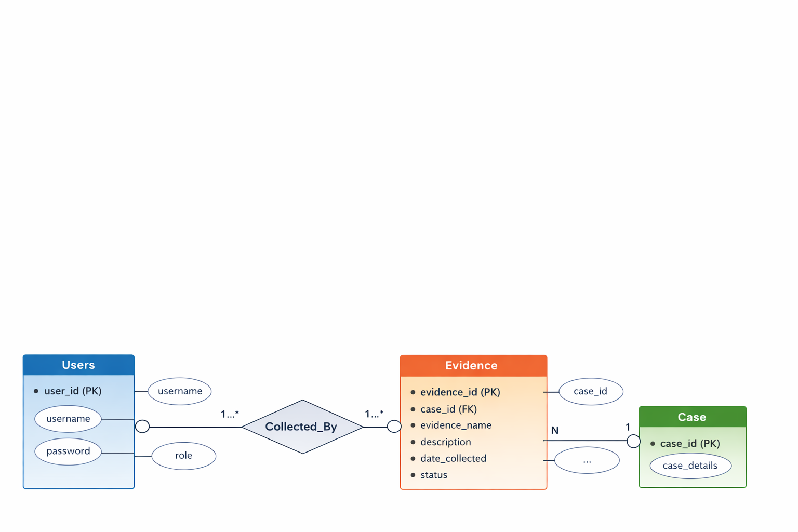

7.5 Data Flow Diagram (DFD)
Level 0 DFD (Context Diagram)
User/Admin → Digital Evidence Management System → Database
The system receives:
• Login credentials
• Evidence details
• Case ID for search
• Status update inputs
The system provides:
• Evidence records
• Officer-specific records
• Case-wise reports
• Complete evidence reports

Level 1 DFD
The system is divided into processes:
- User Authentication
- Manage Evidence
- Search Evidence
- Update Status
- Generate Reports
Data flows between:
User → Application Modules → MySQL Database

7.6 Module Design
1. Login Module
• Accept username and password
• Validate credentials
• Provide role-based access
File: UserDAO.java

2. Evidence Management Module
• Add Evidence
• View Evidence
• Search by Case ID
• Update Status
• Delete Evidence (Admin only)
File: EvidenceDAO.java

3. Report Generation Module
• Generate All Evidence Report
• Generate Officer-wise Report
• Generate Case-wise Report
File: ReportGenerator.java

7.7 Input Design
Inputs are provided through console:
• Username and password
• Case ID
• Evidence name
• Description
• Collection date
• Status
• Evidence ID for updates
Input validation includes:
• Date format validation
• Role-based restrictions
• Case ID input handling

7.8 Output Design
Outputs displayed include:
• Structured evidence list
• Case-wise filtered records
• Officer-wise filtered records
• Status update confirmation
• Report generation output
• Success/Failure messages
Output format is displayed in tabular structure using formatted printing.

CHAPTER 8 - IMPLEMENTATION

Introduction

Implementation is the stage where the system design is converted into a working application.
The Digital Evidence Management System (DEMS) is implemented using:
- Core Java
- MySQL Database
- JDBC Connectivity
The system provides authentication, evidence management, and report generation features with role-based access control.
Development Environment
Software Used
- Java JDK 8+
- MySQL Server 8.x
- Eclipse IDE
- MySQL JDBC Driver
Hardware Used
- Minimum 4GB RAM
- Windows OS
- Intel i3 Processor or above

8.3 Database Implementation
8.3.1 Create Database
CREATE DATABASE digital_evidence;
USE digital_evidence;

Users Table
CREATE TABLE users (
user_id INT PRIMARY KEY AUTO_INCREMENT,
username VARCHAR(50) UNIQUE NOT NULL,
password VARCHAR(100) NOT NULL,
role VARCHAR(20) NOT NULL
);
Insert Users
INSERT INTO users (username, password, role) VALUES
('admin', 'admin123', 'ADMIN'),
('meena', 'meena123', 'OFFICER'),
('arjun', 'arjun123', 'OFFICER'),
('kiran', 'kiran123', 'OFFICER'),
('manswini', 'manswini123', 'OFFICER'),
('dev', 'dev123', 'OFFICER'),
('sneha', 'sneha123', 'OFFICER'),
('ajay', 'ajay123', 'OFFICER'),
('kavya', 'kavya123', 'OFFICER'),
('rohit', 'rohit123', 'OFFICER'),
('pooja', 'pooja123', 'OFFICER');

Evidence Table
CREATE TABLE evidence (
evidence_id INT PRIMARY KEY AUTO_INCREMENT,
case_id VARCHAR(50) NOT NULL,
evidence_name VARCHAR(100) NOT NULL,
description TEXT NOT NULL,
collected_by VARCHAR(50) NOT NULL,
date_collected DATE NOT NULL,
status VARCHAR(50) NOT NULL,
FOREIGN KEY (collected_by) REFERENCES users(username)
);

Insert Evidence Records
INSERT INTO evidence (case_id, evidence_name, description, collected_by, date_collected, status) VALUES
('CASE101', 'Fingerprint Sample', 'Fingerprint collected from crime scene door', 'meena', '2026-03-01', 'Collected'),
('CASE102', 'CCTV Footage', 'CCTV footage from bank entrance', 'meena', '2026-03-02', 'Under Investigation'),
('CASE101', 'Blood Sample', 'Blood stain found near window', 'arjun', '2026-03-03', 'Sent to Lab'),
('CASE200', 'Mobile Phone', 'Suspect mobile phone seized', 'kiran', '2026-03-04', 'Seized');

Java Implementation
The system is divided into the following classes:
- DBConnection
- UserDAO
- EvidenceDAO
- Main
- ReportGenerator

Database Connection Class
public class DBConnection {
private static final String URL = "jdbc:mysql://localhost:3306/digital_evidence";
private static final String USER = "root";
private static final String PASSWORD = "root";
public static Connection getConnection() {
try {
Class.forName("com.mysql.cj.jdbc.Driver");
return DriverManager.getConnection(URL, USER, PASSWORD);
} catch (Exception e) {
System.out.println(e);
return null;
}
}
}

User Login (Authentication)

public String login(String username, String password) {
String query = "SELECT role FROM users WHERE username=? AND password=?";
try {
Connection con = DBConnection.getConnection();
PreparedStatement ps = con.prepareStatement(query);
ps.setString(1, username);
ps.setString(2, password);
ResultSet rs = ps.executeQuery();
if (rs.next()) {
return rs.getString("role");
}
} catch (Exception e) {
System.out.println(e);
}
return null;
}
This method ensures role-based access control.

Add Evidence
public void addEvidence(String caseId, String name, String description,
String collectedBy, String date, String status) {
try {
Connection con = DBConnection.getConnection();
PreparedStatement ps = con.prepareStatement(
"INSERT INTO evidence(case_id, evidence_name, description, collected_by, date_collected, status) VALUES(?,?,?,?,?,?)"
);
ps.setString(1, caseId);
ps.setString(2, name);
ps.setString(3, description);
ps.setString(4, collectedBy);
ps.setString(5, date);
ps.setString(6, status);
ps.executeUpdate();
System.out.println("Evidence Added Successfully!");
} catch (Exception e) {
System.out.println(e);
}
}

View Evidence
public void viewAllEvidence() {
try {
Connection con = DBConnection.getConnection();
Statement stmt = con.createStatement();
ResultSet rs = stmt.executeQuery("SELECT * FROM evidence");
while (rs.next()) {
System.out.println(
rs.getInt("evidence_id") + " | " +
rs.getString("case_id") + " | " +
rs.getString("evidence_name") + " | " +
rs.getString("collected_by") + " | " +
rs.getString("status")
);
}
} catch (Exception e) {
System.out.println(e);
}
}

Update Evidence Status
public void updateStatus(int id, String status) {
try {
Connection con = DBConnection.getConnection();
PreparedStatement ps = con.prepareStatement(
"UPDATE evidence SET status=? WHERE evidence_id=?"
);
ps.setString(1, status);
ps.setInt(2, id);
ps.executeUpdate();
System.out.println("Status Updated Successfully!");
} catch (Exception e) {
System.out.println(e);
}
}

8.4.6 ReportGenerator Class
This class generates:
- Complete Evidence Report
- Officer-wise Report
- Case-wise Report
(Include your corrected full ReportGenerator code here — with System.out.println("Total Records: " + count);)

Console Menu Implementation
After login:
Admin Menu
- Add Evidence
- View All Evidence
- Update Status
- Delete Evidence
- Generate Reports
- Logout
Officer Menu
- Add Evidence
- View My Evidence
- Update Status
- Generate My Report
- Logout
User selections are handled using Scanner.
Testing During Implementation
The following tests were conducted:
- Database connection test
- Login validation test
- Add evidence test
- Update status test
- Foreign key validation
- Officer report filtering
- Case-wise report verification
- Exception handling test
All functionalities worked successfully.
Security Measures Implemented
- Role-based authentication
- Prepared Statement to prevent SQL injection
- Foreign key constraint for data integrity
- Structured exception handling
- Input validation

Screenshots Included in Documentation

Register :

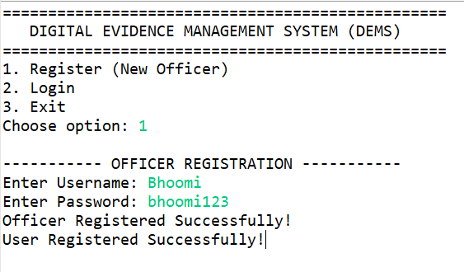

Login:

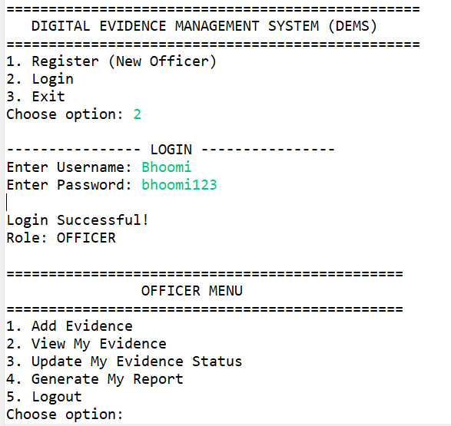

TO add the new evidence:

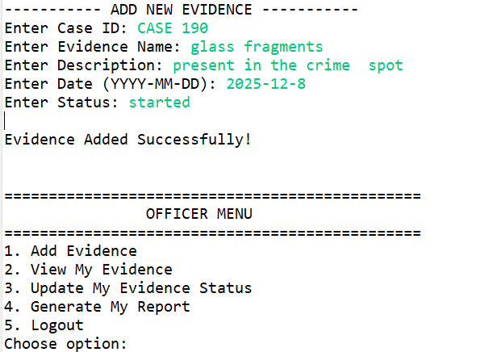

View evidence as per officer:

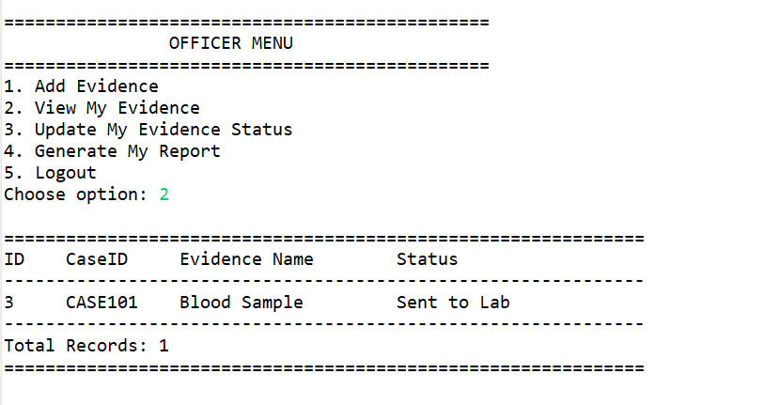

Update the evidence:

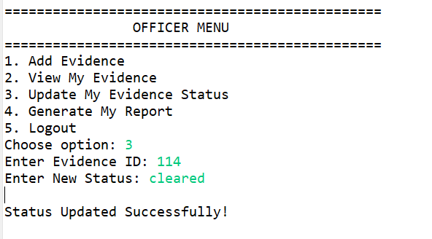

Generate the report
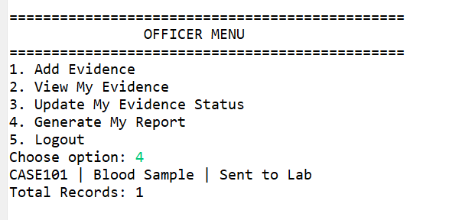

Logout
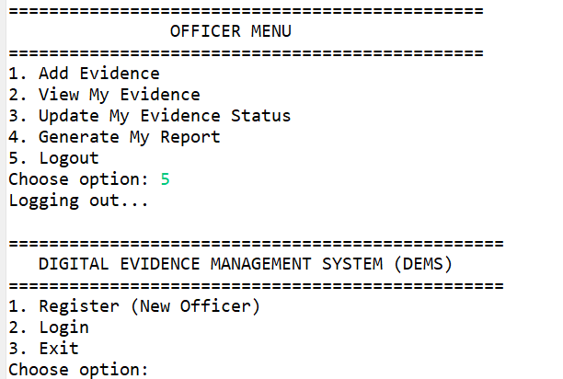

CHAPTER 9 – System testing

Introduction
Testing is the process of verifying whether the developed system works according to the specified requirements. It ensures that the system is free from errors and performs the expected operations correctly.
The Digital Evidence Management System (DEMS) was tested using multiple test cases to validate authentication, database operations, evidence management, report generation, and role-based access control.

Types of Testing Performed
The following types of testing were conducted:

1. Unit Testing
Each module such as:
- User (Login & Registration)
- Evidence
- Reports
was tested individually to ensure correct functionality.

2. Integration Testing
The interaction between:
- Java Application
- MySQL Database
through JDBC connectivity was tested.

3. System Testing
The entire application was tested as a complete working system including Admin and Officer roles.

4. Validation Testing
User inputs were validated to prevent:
- Empty fields
- Invalid dates
- Incorrect credentials
- Invalid menu selections

9.3 Test Case Tables
Below are detailed test cases for major modules.

9.3.1 User Module Test Cases
Test Case ID | Test Description | Input | Expected Output | Actual Output | Status
TC_U01 | Register new officer | Username: arun | Registration successful | Registration successful | Pass
TC_U02 | Register with existing username | Username: admin | Error: Username exists | Error displayed | Pass
TC_U03 | Login with valid credentials | admin / admin123 | Login successful | Login successful | Pass
TC_U04 | Login with invalid credentials | admin / wrongpass | Invalid credentials | Error displayed | Pass

9.3.2 Evidence Module Test Cases
Test Case ID | Test Description | Input | Expected Output | Actual Output | Status
TC_E01 | Add new evidence | CASE101, Fingerprint | Evidence added successfully | Evidence added successfully | Pass
TC_E02 | View all evidence | Select View option | Display all records | Records displayed | Pass
TC_E03 | Update evidence status | ID = 2 | Status updated | Status updated | Pass
TC_E04 | Delete evidence | ID = 3 | Evidence deleted | Evidence deleted | Pass
TC_E05 | Add evidence with empty case ID | "" | Error message | Error displayed | Pass

9.3.3 Report Module Test Cases
Test Case ID | Test Description | Input | Expected Output | Actual Output | Status
TC_R01 | Generate full report | Select option 5 | Display all evidence | Report generated | Pass
TC_R02 | Generate officer report | Officer: meena | Display officer records | Records displayed | Pass
TC_R03 | Generate case-wise report | CASE101 | Display case records | Records displayed | Pass

9.4 Database Testing
The following database validations were tested:
• Primary Key constraint on users.user_id and evidence.evidence_id
• Unique constraint on username
• Foreign Key constraint between evidence.collected_by and users.username
• Auto-increment functionality
• Proper insertion and retrieval of records
• Deletion without violating referential integrity
All constraints worked successfully without errors.

9.5 Error Handling Testing
The system was tested for:
• Invalid menu options
• Wrong login credentials
• Empty input fields
• Invalid evidence ID for update/delete
• Database connection failure
Proper exception handling ensured the system did not crash and displayed meaningful error messages.

9.6 Performance Testing
Basic performance testing was conducted by:
• Inserting multiple evidence records
• Generating large reports
• Testing login for multiple users
The system responded efficiently without noticeable delay.

CHAPTER – 10

RESULTS AND DISCUSSION

10.1 Introduction
This chapter presents the outcomes of the Digital Evidence Management System after implementation and testing. It evaluates how effectively the system meets its objectives.

10.2 Results Obtained
After successful implementation and testing, the following results were observed:

1. Successful Database Integration
The Java application successfully connected with the MySQL database using JDBC.
All CRUD operations were performed correctly.

2. Proper User Management
The system was able to:
• Register new officers
• Authenticate users
• Enforce role-based access control
Only authorized users could access specific functionalities.

3. Efficient Evidence Management
The system successfully allowed:
• Adding digital evidence
• Viewing all evidence (Admin)
• Viewing personal evidence (Officer)
• Updating evidence status
• Deleting records
All operations were reflected accurately in the database.

4. Report Generation
The system generated:
• Complete evidence report
• Officer-wise report
• Case-wise report
Reports displayed total record count and structured table formatting.

5. Data Integrity Maintained
• Primary and foreign key constraints ensured valid relationships.
• PreparedStatement prevented SQL injection.
• Structured exception handling avoided system crashes.

10.3 Discussion
The Digital Evidence Management System successfully replaces manual evidence tracking methods.
Compared to manual systems:
• Data retrieval is faster
• Errors are reduced
• Role-based access improves security
• Evidence tracking is structured
• Reports are generated instantly
However, the current system:
• Is console-based (no GUI)
• Does not support file uploads of evidence
• Does not support multi-user concurrency
These features can be implemented in future enhancements.

10.4 Achievement of Objectives
Objective | Status
Implement role-based authentication | Achieved
Manage digital evidence records | Achieved
Generate structured reports | Achieved
Maintain centralized database | Achieved
Ensure data integrity | Achieved
Improve evidence tracking efficiency | Achieved

CHAPTER – 11

CONCLUSION

11.1 Conclusion
The Digital Evidence Management System (DEMS) was developed to improve the management and tracking of digital evidence in an organized and secure manner.
The system successfully integrates:
• Java (Core Programming)
• MySQL Database
• JDBC Connectivity
• SQL Queries
• Role-Based Access Control
The system ensures:
• Secure login authentication
• Controlled access for Admin and Officers
• Efficient evidence management
• Structured report generation
• Data integrity through database constraints
All project objectives were successfully achieved. The system performed effectively during testing and proved to be a reliable solution for managing digital evidence records.
Thus, DEMS serves as a practical and scalable solution for law enforcement or organizational evidence management systems.

